IAA-BR-16-0S-0P  
  
Paper Title  
  
Main Author[1]*, Co-Author[2]**.

A one paragraph abstract of no more than 400 words must be included at the beginning of the manuscript. It should be a summary and complete in itself (no references to the main body of the manuscript). The abstract should indicate the subjects dealt within the full text and should state the objectives of the investigation. Newly-observed facts and conclusions of the experiment or argument discussed in the full text must be stated in this summary. Readers should not have to read the full text to understand the abstract. The abstract can be an updated version of the one submitted at the call-for-abstracts but its contents must not differ substantially from the later.

Major Headings

Major Headings must be in Title Case and Bolt, Times New Roman 12 or similar, in left side.

1. Subheadings

Subheadings are bolted and in italic style, placed flush on the left band margin of the column.

Sub-subheadings

Sub-subheadings are underlined and indented

Style Guide

1. Acronyms

Always use the full title followed by the acronym to be used..

2. References

List and number all the bibliographical references at the end of the full text, in the order of appearance [1]

3. Equation Numbers

When numbering equations, enclose numbers in brackets and place flush right with the right band margin of the column.

 [1]

4. Illustrations and Captions

It is important to remember that all artwork, captions, figures, graphs and tables will be reproduced exactly as you submitted them. (Company logos and identification numbers are not permitted on your illustrations).

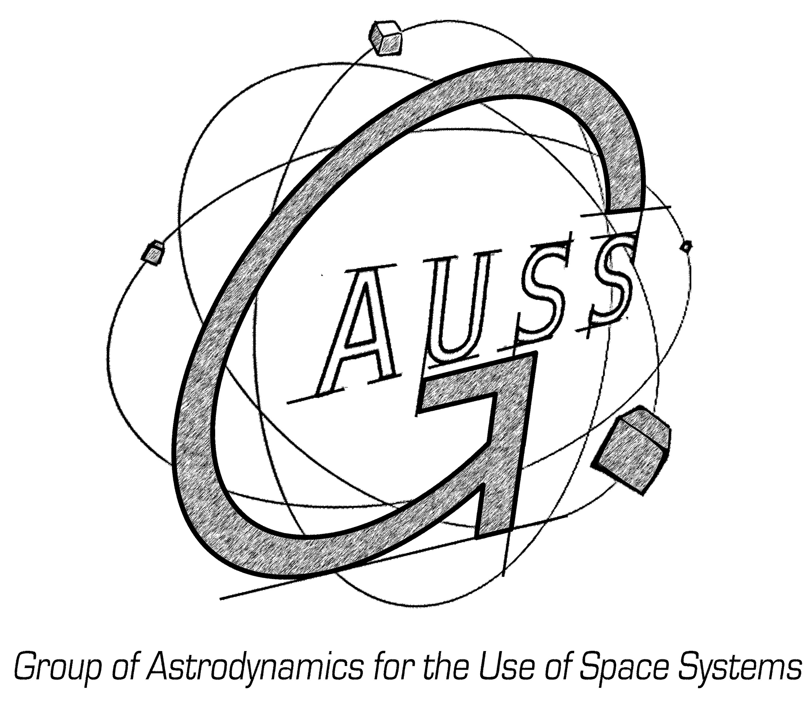

Fig. 1. Title of the figure, left justified, subsequent text indented. Place figures as close as possible to the first references to them in the manuscript. Use only black and white image. Font: Times New Roman 9.5.

5. Graph Lines, Drawings and Tables

Use black ink on white manuscript and ensure that they remain still readable.

|  |  |
| --- | --- |
| Xxxx | Yyyy |
| ABC | ~30 SI units |
| DEF | ~14 SI units |
| Total | ~44 SI units |

Table X. Title of table, left justified, subsequent text indented. Heading centered. Do not use vertical lines within the table..

5. Captions, Graph Axes, Legends

Captions, graph axes, legends, etc. should be large enough to remain readable.

6. Footnotes, Symbols and Abbreviations

Footnotes should be cited using numbers. Use only standard symbols and abbreviations in text and illustrations.

7. Page Numbers

Indicate page numbering at the top of each page with outside alignment.

References

[1] Author, Co-Authors: *Title*, YEAR, Journal Number, pages 12-13,

1. ### * Affiliation, Country, email address

  
2. ** Affiliation, Country, email address